1. What is our independent variable? What is our dependent variable?

The independent variable is the congruent condition or incongruent condition

The dependent variable is the time it takes to name the ink colors

1. What is an appropriate set of hypotheses for this task? What kind of statistical test do you expect to perform? Justify your choices.

µ1: the population mean of the time it takes to name the ink colors in congruent condition

µ2: the population mean of the time it takes to name the ink colors in incongruent condition

H0: µ1= µ2

The time it takes to name the ink colors have no significant difference between in the congruent words condition and in the incongruent words condition.

Ha: µ1≠ µ2

The time it takes to name the ink colors have significant difference between in the congruent words condition and in the incongruent words condition.

I choose two tailed paired t-test

Justifications:

- We do not know population parameters, so we use T-test

- We don’t need to know if µ1 is greater than or less than µ2, we just want to know if they are equal to or not equal to each other, so we use two tailed t-test

- we test between dependent observations the same group of subjects participate in two difference conditions , so we use two tailed dependent paired t-test.

1. Report some descriptive statistic regarding this dataset. Include at least one measure of central tendency and at least one measure of variability.

Measure of central tendency:

The number of the sample: n = 24

The mean of the sample of congruent: $EQ \backslash x \backslash to(x1)$ =14.05

The mean of the sample of incongruent: $EQ \backslash x \backslash to(x2)$ = 22.02

Measure of variability:

The standard deviation of the sample of congruent: S1 = = 3.60

The standard deviation of the sample of incongruent: S2 = = 4.80

The standard deviation of the difference Sd= 4.86

1. Provide one or two visualizations that show the distribution of the sample data. Write one or two sentences nothing what you observe about the plot or plots.

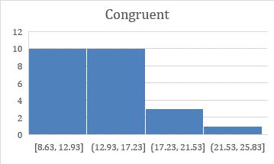 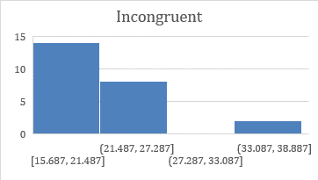

The distributions of the samples of congruent and incongruent both show as positive skew distributions, which means the outliers are present in the right side of the distribution

1. Now perform the statistical test and report your results. What is your confidence level and your critical statistic value? Do you reject the null hypothesis or fail to reject it? Come to a conclusion in terms of experiment task. Did the results match up with your expectations

We will calculate the t-critical value at an alpha(α) level of 0.05 for two tailed t- test, the confidence level is 95%

The degree of freedom:

df = n-1 = 23

The t-critical value:

-2.069/+2.069

T-statistic:

t= $\frac{ EQ \backslash x \backslash to(x1) - EQ \backslash x \backslash to(x2) }{Sd/\sqrt{n}}$-8.02

As the t-statistic= -8.02 is much less than the t-critical value -2.069, which means the p-value is much less than 0.025, so we do reject H0.

The time it takes to name the ink colors do have significant difference between in the congruent words condition and in the incongruent words condition. This is exactly match my expectations.

1. Optional: What do you think is responsible for the effects observed? Can you think of an alternative or similar task that would result in a similar effect? Some research about the problem will be helpful for thinking about these two questions!

I think the same participants take the experiments in different conditions two times in a short interval and he will be familiar with the spelling and pronunciation of the color names at the second time, this should responsible for the effects observed.

Alternative or similar task:

Most of the part are the same with the stroop task, except run the second condition at the same time of the second day to reduce the short memory of the color words effect.